Recommended Social Copy:
Lung Cancer Screening
PSA Copy:
Below you will find suggested copy to share the Lung Cancer Screening campaign on your social channels. Social media graphics can be downloaded on the Saved By The Scan campaign toolkit.
Facebook
Lung cancer is the number one cancer killer of men and women. But no matter how much you smoked, early detection of lung cancer could save you. Learn more and see if you’re eligible for screening at SavedByTheScan.org https://www.youtube.com/watch?v=ds3oCZYvtB8
Approximately 9 million people in the U.S. are at high-risk for lung cancer and eligible for screening. See if you could be #SavedByTheScan and take the quiz. https://www.youtube.com/watch?v=ds3oCZYvtB8
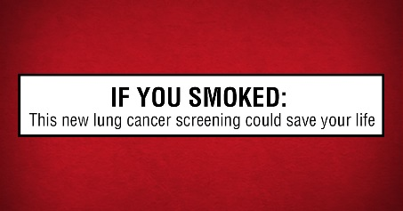
This new PSA from the Ad Council and the American Lung Association’s LUNG FORCE initiative sends a powerful message that early detection of lung cancer could save lives. https://www.youtube.com/watch?v=ds3oCZYvtB8

Eva-Marie quit after smoking 12,000 packs of cigarettes. Thanks to the new lung cancer screening, no matter how much you smoked, early detection could save your life. If you have a similar story, visit SavedByTheScan.org. https://www.youtube.com/watch?v=ds3oCZYvtB8
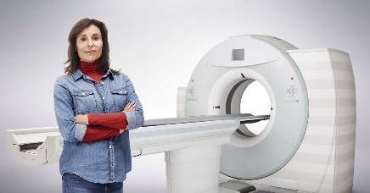
Get Saved By The Scan. Take the quiz to see if you should get screened for lung cancer. https://www.youtube.com/watch?v=ds3oCZYvtB8
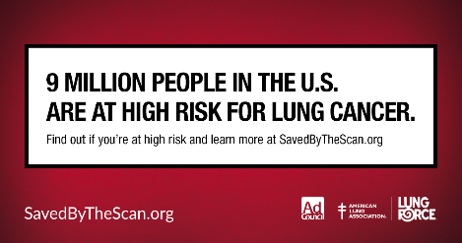
If only half of the 9 million Americans at high-risk for lung cancer got screened, thousands of lives could be saved. See if you or a loved one could be #SavedByTheScan by taking the lung cancer screening eligibility quiz. https://www.youtube.com/watch?v=ds3oCZYvtB8
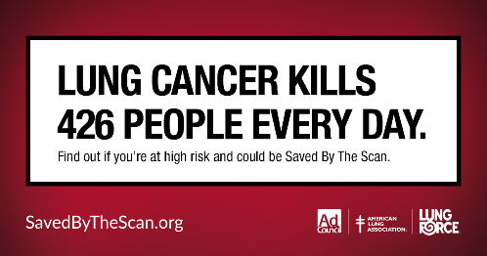
If you’re a former smoker between 55 and 80 years old who quit within the last 15 years, early detection could save your life. Visit SavedByTheScan.org to learn more. https://www.youtube.com/watch?v=ds3oCZYvtB8
Twitter
Get #SavedByTheScan with this #lungcancer screening eligibility quiz at SavedByTheScan.org https://www.youtube.com/watch?v=ds3oCZYvtB8
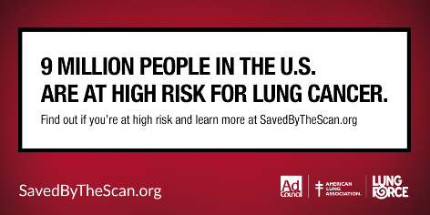
Are you a former smoker? Go to SavedByTheScan.org and learn if you’re eligible for #lungcancer screening. https://www.youtube.com/watch?v=ds3oCZYvtB8
Quit smoking? Learn if you’re eligible to be #SavedByTheScan and take this quiz at SavedByTheScan.org https://www.youtube.com/watch?v=ds3oCZYvtB8
If you are a former smoker, you may still be at risk for #lungcancer. SavedByTheScan.org could save your life https://www.youtube.com/watch?v=ds3oCZYvtB8
Eva-Marie quit after smoking 12,000 packs of cigarettes. Then she got screened. Watch her story & see if you could be #SavedByTheScan https://www.youtube.com/watch?v=ds3oCZYvtB8
You quit smoking. Now start screening. Take the quiz to see if you should get screened at SavedByTheScan.org #SavedByTheScan
#LungCancer survival rates are 5X higher if it’s detected early. See if you’re eligible to get #SavedByTheScan at SavedByTheScan.org
Instagram
Lung cancer is the number one cancer killer of men and women. But no matter how much you smoked, early detection of lung cancer could save you. Learn more and see if you’re eligible for screening at SavedByTheScan.org
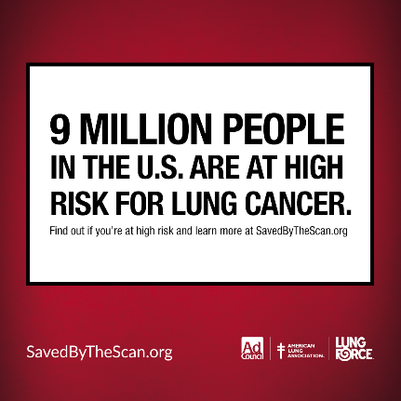
Approximately 9 million people in the U.S. are at high-risk for lung cancer and eligible for screening. Go to SavedByTheScan.org and take the quiz.
This new PSA from the Ad Council and the American Lung Association’s LUNG FORCE initiative sends a powerful message that taking the lung cancer screening eligibility quiz at SavedByTheScan.org could save lives.
Eva-Marie quit after smoking 12,000 packs of cigarettes. Thanks to the new lung cancer screening, no matter how much you smoked, early detection could save your life. If you have a similar story, visit SavedByTheScan.org.

Get Saved By The Scan. Take the quiz at SavedByTheScan.org to see if you should get screened for lung cancer.
If only half of the 9 million Americans at high-risk for lung cancer got screened, thousands of lives could be saved. Go to SavedByTheScan.org and see if you or a loved one are eligible for screening.
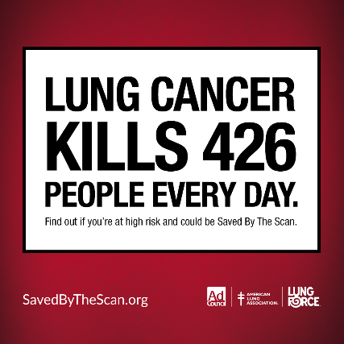
If you’re a former smoker between 55 and 80 years old who quit within the last 15 years, early detection could save your life. Visit SavedByTheScan.org to learn more.

